* **Activity 4:**

Using Conversion Functions and Conditional Expressions

1. **Use TO_CHAR to convert a date-time data type to VARCHAR2:**

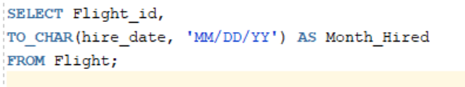

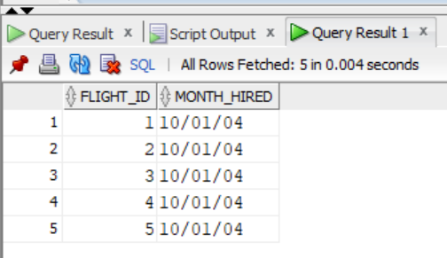Output:

1. **Display employees hired before 1990 using RR date format:**

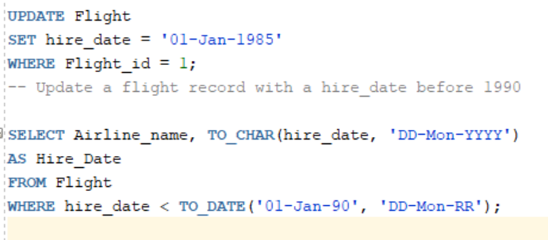

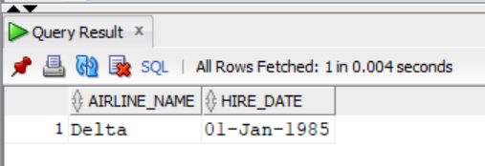Output: